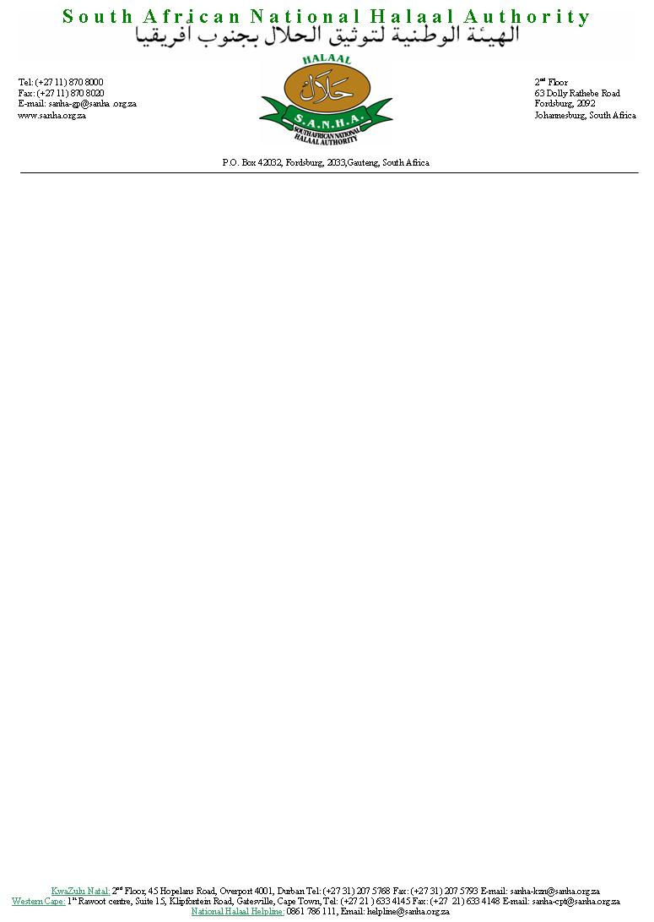
.

LAYS, PAKISTAN IS HALAAL

The South African National Halaal Authority (SANHA) is an internationally recognised organisation, and an acknowledged authority on all matters pertaining to the general application of the term Halaal with specific reference to Islamic dietary laws.

SANHA has been established as a representative authority, which promotes professionalism and excelled in developing systems for the certification of Halaal food and other related products. SANHA is committed to standardizing Halaal procedures internationally thereby rendering a tangible and credible service to both the consumer and the industry. Indeed, this strategy does not only prove beneficial for the Muslim consumer but is also a means of promoting trade.

SANHA is among the founding members represented on the World Halaal Council and enjoys global recognition from both Muslim and Western Countries.

SANHA has over the past several years rendered assistance to the Halaal industry in Pakistan and hass issued Halaal certification to several Pakistani companies: some of whom are listed below:
- Dawn Bakeries
- Youngs Foods (Pvt) Ltd
- Shangrila (Pvt) Ltd
- Candyland
- Bisconni
- Snack City
- Leiner Pak
- Haleeb Foods Ltd
- Freshmate Ready Meals

The hoax chain email of some unknown, mysterious Dr Amjad Khan regarding E-numbers which has been doing the rounds for several years is grossly inaccurate and very misleading with mischievous intent. All efforts by our organization to trace this person, if he indeed exists, has not yielded any results.

Contd..pg 1 of 2

Halaal certification authorities, food technologists and industry professionals who are au fait with E-additives and food ingredients will bear testimony to the fallacies and baseless claims of the said email.

Recently, Lays Pakistan has regrettably been bearing the brunt of Dr Amjad’s mail and consumers have been misled into believing that E-631, is a derivative of PIG.

SANHA, an International Halaal certification authority has investigated the ingredients used by LAYS Pakistan and can confirm that their ingredients are Halaal compliant. Infact the E-631 used by LAYS Pakistan is derived from TAPIOCA STARCH, a plant based raw material which has been certified Halaal.

Consumers are advised to be wary of such malicious emails and urged not to circulate any such mail until the information has been verified and confirmed by a reputable expert authority.

For all Halaal related queries, you may contact the Halaal Helpline on helpline@sanha.org.za

Remember the Islamic Rule, “Verify Before You Amplify”!

Was-Salâm
For South African National Halaal Authority

M.S. Navlakhi (Moulana) M.Y. Seedat (Mufti)
Theological Director Theological Representative

(ELECTRONICALLY TRANSMITTED – NO SIGNATURES REQUIRED)

